How do the poisons that farmers spray affect them

Zuhtu Gunaydin
CST
Rousse University
Rousse, Bulgaria
Zyuhtyu@gmail.com
_________________
Beydzhan Eredzheb
CST
Rousse University
Rousse, Bulgaria
beycan2003@gmail.com

Introduction

Farmers rely heavily on chemical agents to protect their crops from damage caused by pests, weeds, and diseases. If these chemicals were not used, a significant percentage of crops would be lost to insects, fungi, and competing weeds, leading to global food shortages and higher prices for consumers.
However, the application of these necessary "poisons" presents a severe occupational hazard. Traditional methods often require the farmer to be physically present in the field or greenhouse, wearing protective gear that may fail or be used improperly. The solution to this dilemma lies not in removing the chemicals, but in removing the human from the immediate environment of application.
This paper discusses the integration of IT software and automated systems designed to execute spraying tasks. By using centralized management software, farmers can schedule and execute hazardous operations without physical contact with the toxins.

1.2

1.1

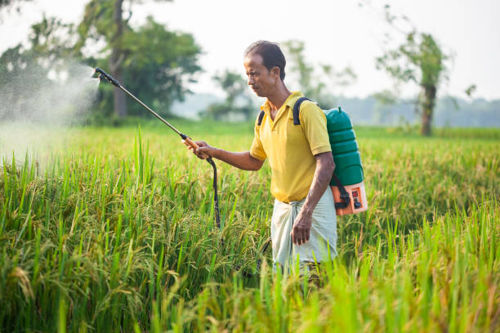
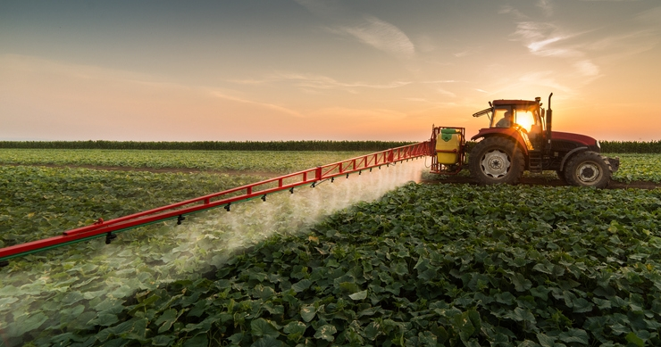

https://www.farmprogress.com/management/10-tips-for-better-spraying-this-spring
https://www.istockphoto.com/photos/farmer-spraying-pesticide-in-the-rice-field

THE PROBLEM: EXPOSURE RISKS
The primary risk in conventional farming is the proximity of the operator to the chemical mist. Despite safety regulations and warning signs, the "danger zone" remains the immediate area where the spraying occurs.
Health organizations and clinics note that long-term exposure can lead to chronic health issues. The goal of modern agricultural engineering is to create a buffer between the toxin and the human. While warning signs (e.g., "DANGER PESTICIDES") serve as a passive deterrent, active prevention requires a technological intervention.
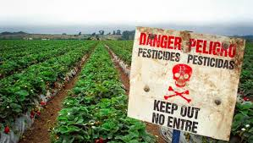
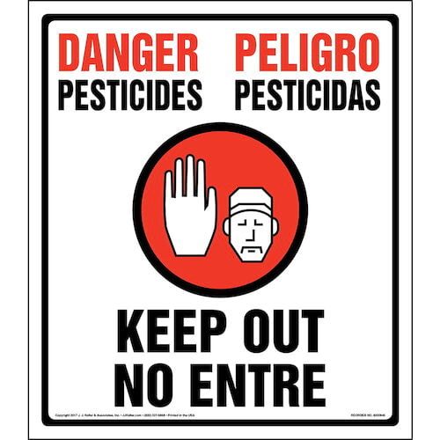

https://www.jjkeller.com/shop/danger-pesticides-keep-out-no-entry-federal-sign?srsltid=AfmBOop8qYY_iXjFyZdR9pmUXUay9PROsw1MUoCHUYc8pdnQ8fCsj1QV
beyondpesticides.org

THE IT SOLUTION: AUTOMATION AND REMOTE CONTROL

To solve the issue of exposure, we propose a shift to Smart Agriculture systems (Precision Farming). This involves hardware (sensors, valves, sprinklers) controlled by a sophisticated software layer.

Architecture of the System
The system consists of a central server or cloud platform that communicates with a local controller in the greenhouse or field.

- User Interface (UI): A web or mobile application where the farmer logs in securely.
- Logic Controller: A program that processes user commands and sensor data.
- Actuators: Electronic valves and misting systems that physically release the chemicals.

Workflow for Safety
Instead of walking through rows of crops with a sprayer, the farmer follows this software-driven workflow:
- Remote Login: The farmer accesses the system from an office or home computer.
- Schedule Configuration: The user inputs the specific time, duration, and type of chemical to be sprayed.
- System Check: The software analyzes environmental conditions (via sensors) to ensure safe application.
- Automated Execution: The system activates the spraying infrastructure. The greenhouse is locked, and alarms are active.
- Completion Report: The system sends a notification to the farmer's device confirming the job is done.

IMPLEMENTATION AND BENEFITS
Real-world implementations, such as those seen in modern smart farms (e.g., Nikolagro projects using ONDO systems), demonstrate the viability of this approach.

Key Safety Benefits:

- Zero Contact: The farmer is never in the greenhouse during the "active" phase of the poison.
- Precise Dosing: Software ensures exactly the right amount is used, reducing chemical runoff.
- Logging and Traceability: The software keeps a digital record of what was sprayed and when, useful for medical safety and legal compliance

CONCLUSION
While pesticides remain a necessary tool for avoiding crop loss, the method of their delivery must evolve. By utilizing IT programs and software automation, we can decouple the act of farming from the risk of poisoning. Technology allows the farmer to protect their crops while maintaining their own health, ensuring that the "poison" affects only the pests, not the people.

REFERENCES
- Beyond Pesticides, "Pesticide-Induced Diseases Database," Beyond Pesticides, Washington, D.C. [Online]. Available: https://beyondpesticides.org. [Accessed: Dec. 13, 2025].
- Scott Free Clinic, "Farming and Pesticide Safety Resources," Scott Free Clinic. [Online]. Available: http://www.scottfreeclinic.org. [Accessed: Dec. 13, 2025].
- ONDO Smart Farming, "Automation in Greenhouse Complexes: Client Case Study Nikolagro," ONDO. [Online]. Available: https://ondo.io/bg/clients/nikolagro/. [Accessed: Dec. 13, 2025].
- Z. Gunaydin and B. Eredzheb, " Dept. of Computer Systems and Technologies Rousse University Rousse, Bulgaria

